The Anguished man

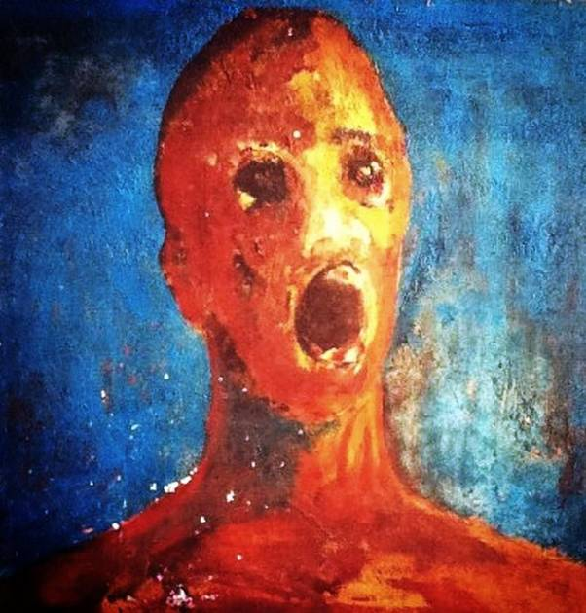

Resources:

1_https://en.wikipedia.org/wiki/The_Anguished_Man

2_https://www.dreadcentral.com/news/124421/the-anguished-man-the-worlds-most-haunted-painting-is-not-for-sale/

3_https://bloody-disgusting.com/movie/3390926/haunted-painting-anguished-man-becoming-movie/

4_https://books.google.jo/books?id=3W4CEAAAQBAJ&pg=PT102&redir_esc=y#v=onepage&q&f=false

5_https://www.youtube.com/@TheAnguishedManOfficial

6_https://books.google.jo/books?id=Sr-5DQAAQBAJ&pg=PA19&redir_esc=y

7_https://theghostinmymachine.com/2023/12/04/encyclopaedia-of-the-impossible-the-anguished-man-painting/.